Sulfide Test Kit for Compost

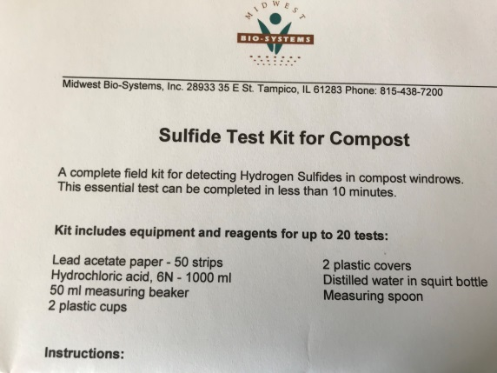
Gather for each test kit:
Lead acetate paper – 50 stripes per
Hydrochloric acid, 6N – 1000 ml
50 ml beaker
2 plastic glasses
2 plastic lids/covers for the glasses
Small squirt bottles filled with distilled water
Measuring spoon

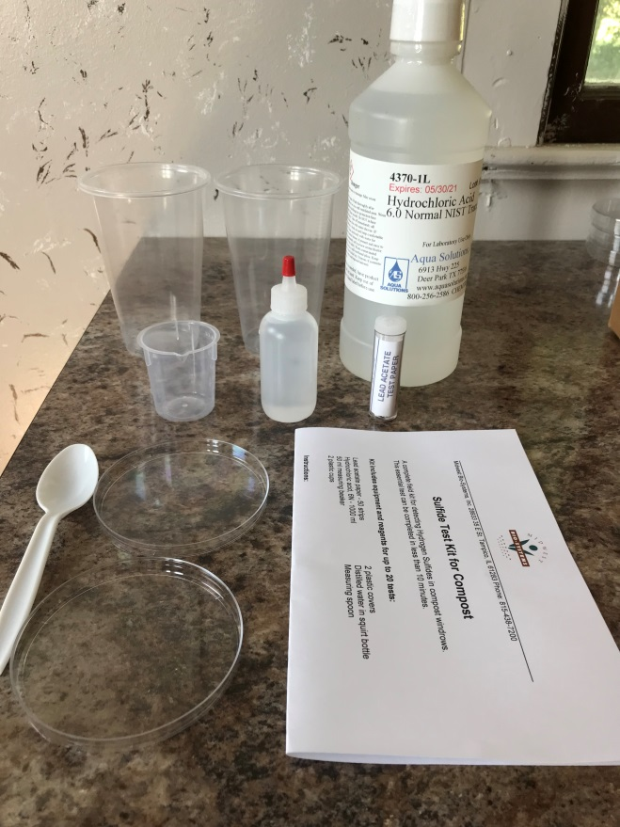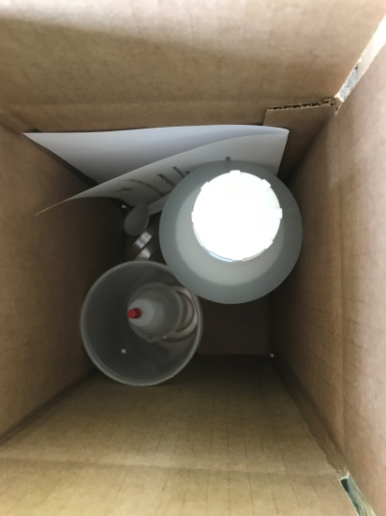
Assemble into a 6x6x10 Box- make sure to include instructions and attach Label to box
